Jenkins - Project's Configuration
Title | Guide to Build Project from Repository
Prepared by | Balaji.V.S

Step 1 : Create new project by clicking New Item menu
* Enter the Project name. FactSheetAutomation
* Choose Freestyle project
* Press OK to create the Project.
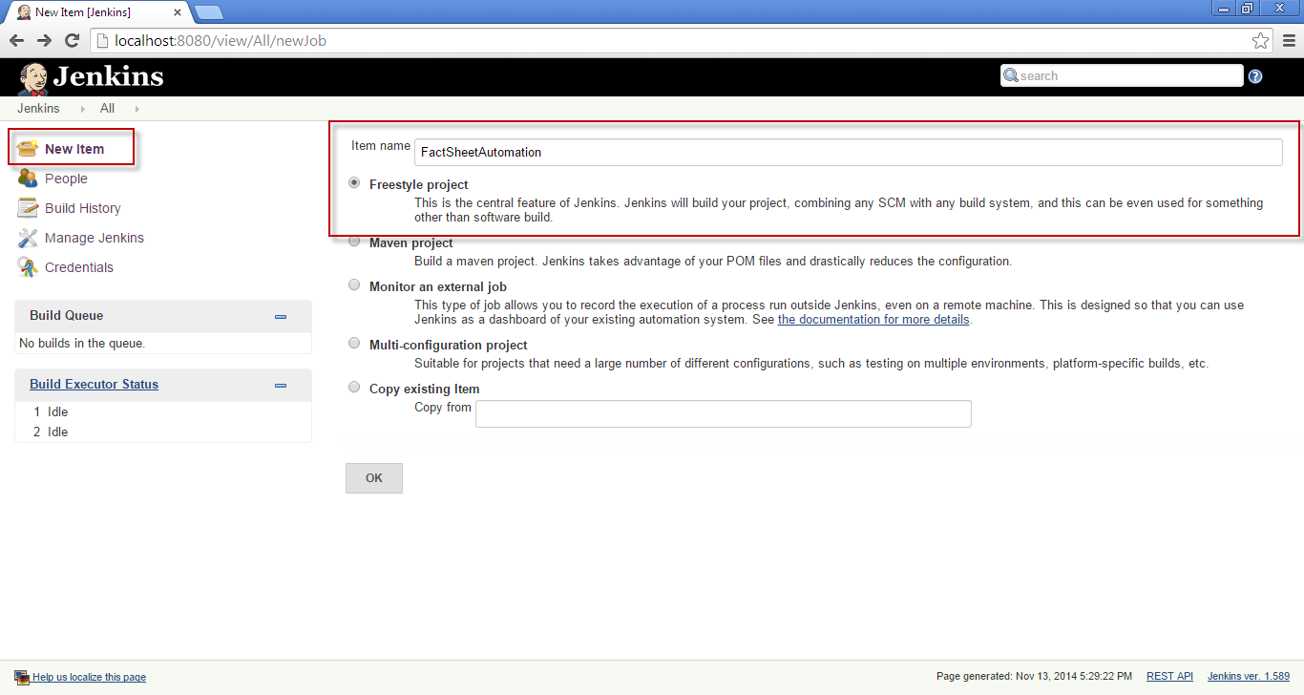
Step 2 : Now Project created as shown below 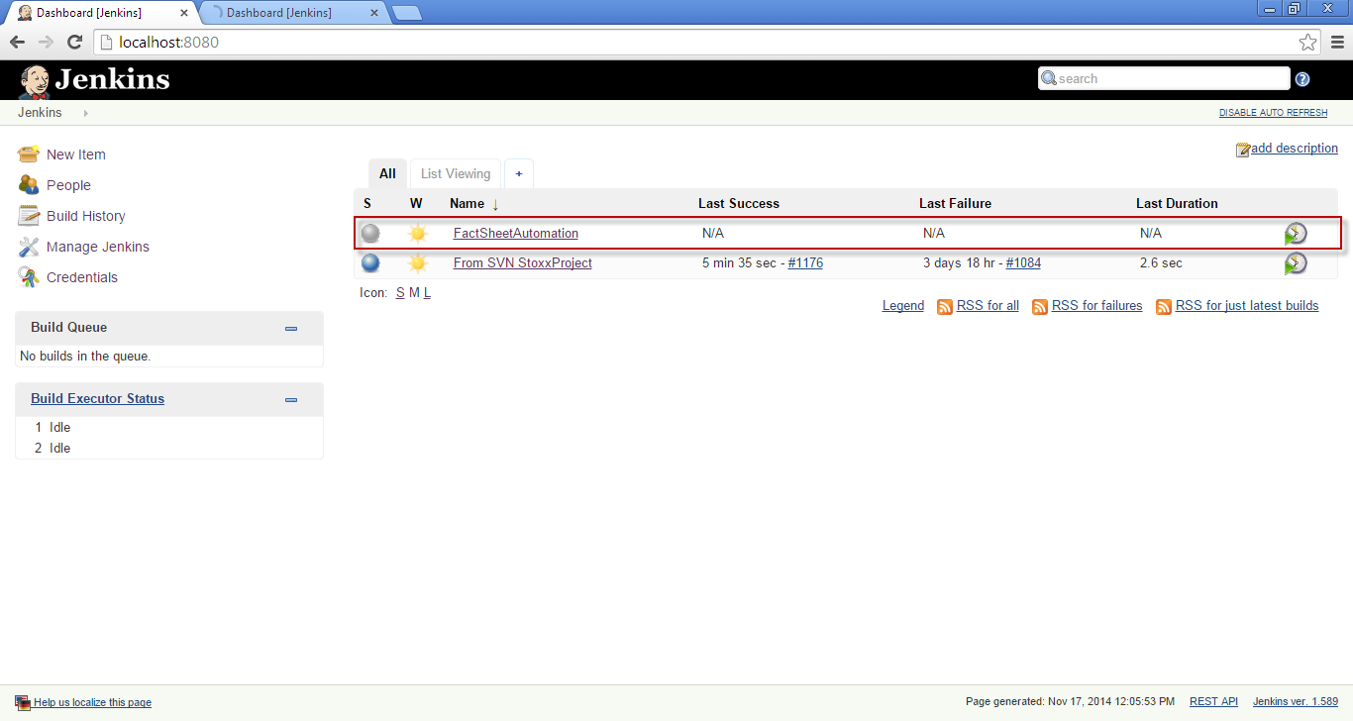

Step 3 : On clicking the Project name FactSheetAutomation, you will project configuration screen.
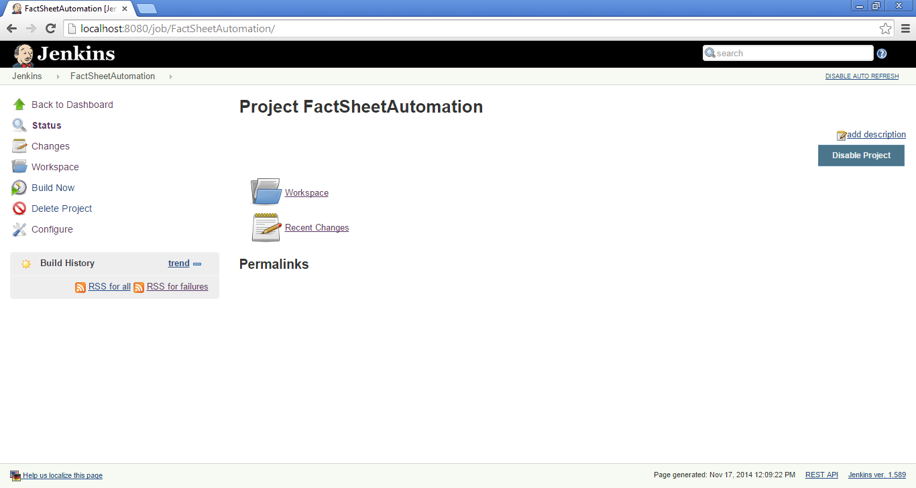

Step 4 : Configuration steps for newly created project ( FactSheetAutomation ).
Step 4.1 : Click configure menu in left pane.
Step 4.2 : Select Source code management . input your project SVN URL in to Reposity URL.

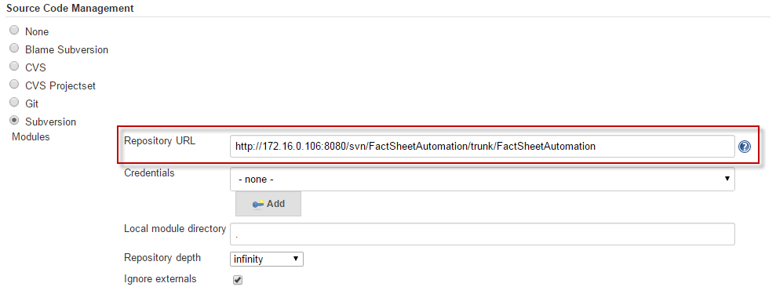
Step 4.3 : Choose Build periodically check box
* In schedule build deployment as shown below period of time
For example : MINUTE HOUR DOM MONTH DOW

Example | Time period format | Build & Deployement action
1) | H/30 * * * * | Every Half an hour.
2) | H 23 * * * | Every day 23:00 hrs at Mid night
3) | H H H * * | Monthly once.
4) | H H H/1,15,29 * * | Monthly thrice 1st ,15th and 29th day.
5) | H H H H * | Yearly once.

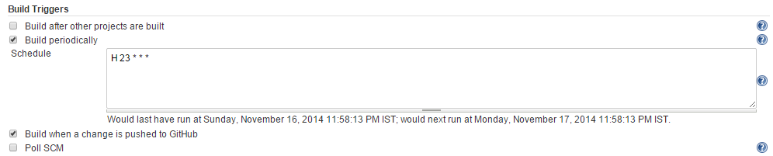

Step 4.4 : On checking out "Build when a change is pushed to GitHub" [optional]
- build and deployment action would occur after changes are pushed into GitHub.
Step 4.5 : On checking " Poll SCM " [optional]
- This option compare workspace files with server files at given scheduled time. if any latest version in server, then build and deployment action made.
Step 5 : Setting up the ANT HOME and Properties
*** Refer Sample build files

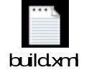

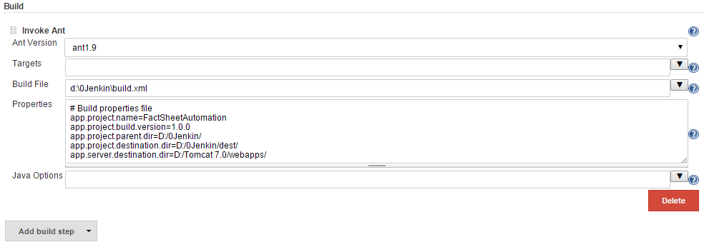

Step 6 : Configuring E-mail Notification
Setting up the Mail configuration. This send mail for every Success and Failure Build & Deployment.
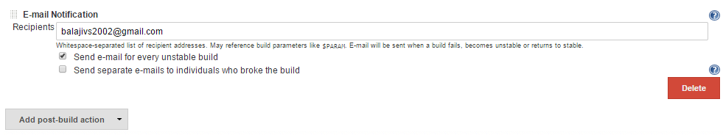
Step 7 : For immediate build click on Build Now in Left pane. 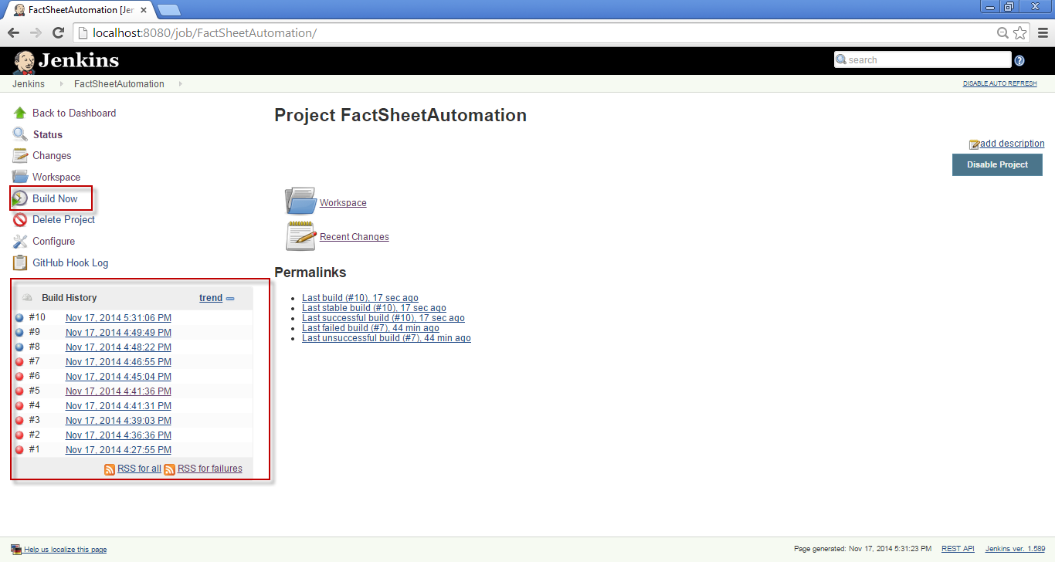
Step 8 : Build History
Build history will list of all Success and Failure with respective marks.

